**Báo cáo thực hành Lập trình hướng đối tượng Lab 1**

Họ và tên: Đỗ Gia Huy

MSSV: 20215060

**I- The Very First Java Programs**

2.2.1- Write, compile the first java application

a. Code:

b. Thực thi:

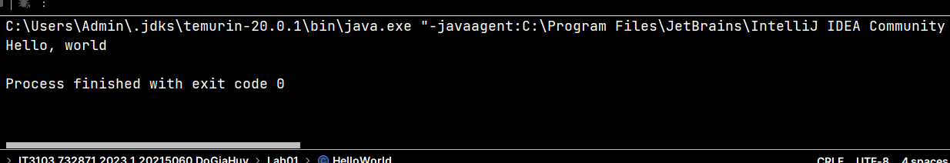

2.2.2- Write, compile the first dialog Java program

a. Code:

b. Thực thi:

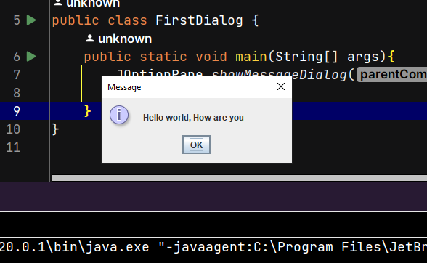

2.2.3- Write, compile the first input dialog Java application

a. Code:

b. Thực thi:

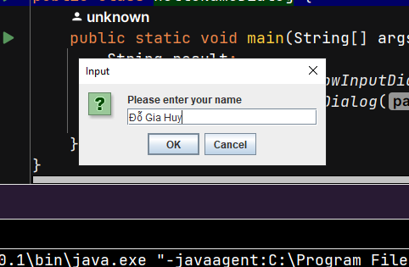

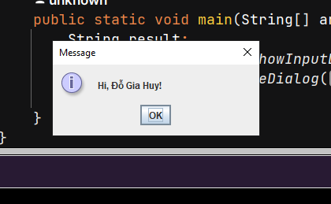

2.2.4- Write, compile, and run the following example:

a. Code:

b. Thực thi:

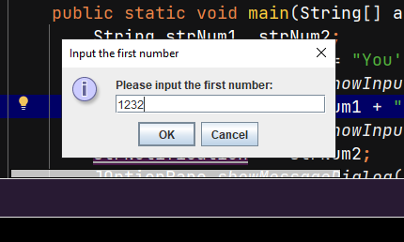

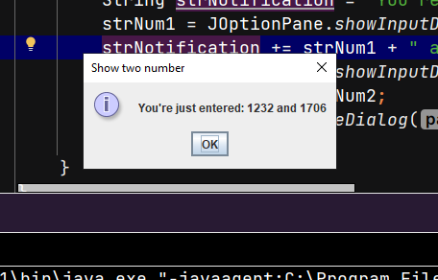

2.2.5- Write a program to calculate sum, difference, product, and quotient of 2 double numbers which are entered by users.

a. Code:

b. Thực thi:

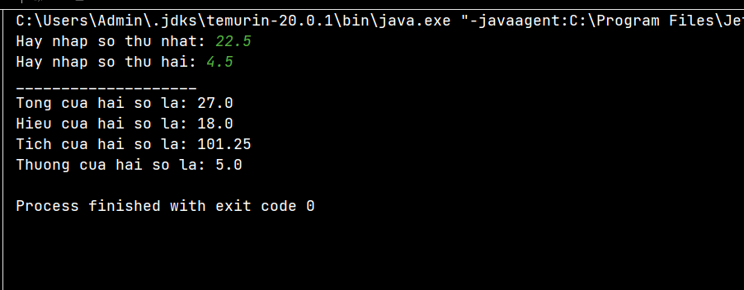

2.2.6- Write a program to solve:

2.2.6.1- The first-degree equation (linear equation) with one variable

a. Code:

b. Thực thi:

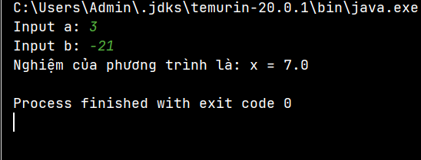

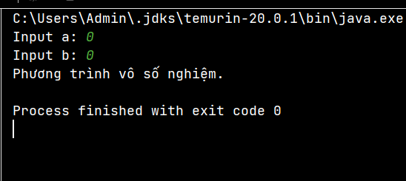

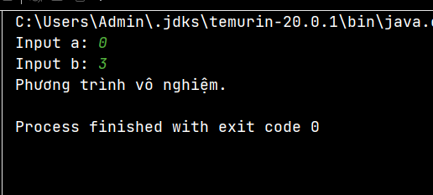

2.2.6.2- The system of first-degree equations (linear system) with two variables

a. Code:

b. Thực thi:

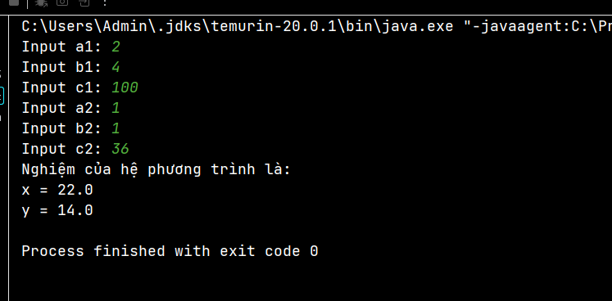

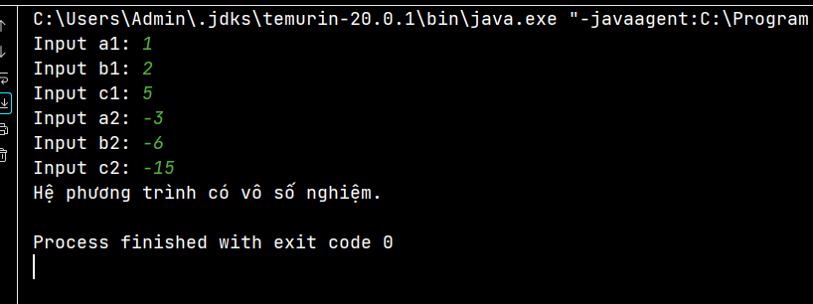

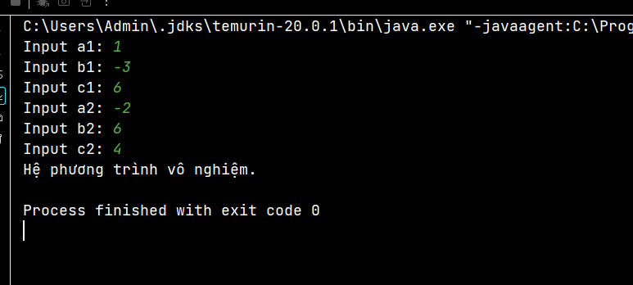

2.2.6.3- The second-degree equation with one variable

a. Code:

b. Thực thi:

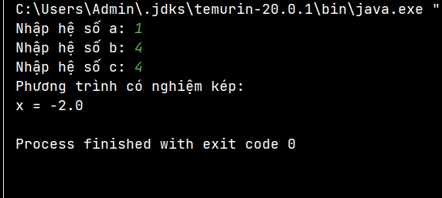

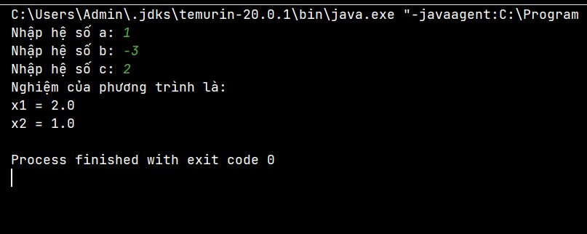

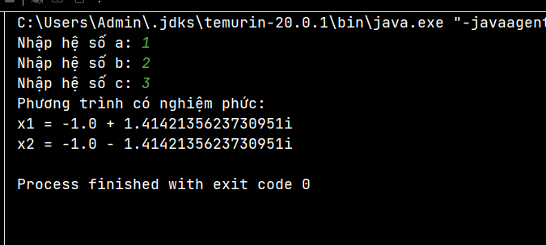

**II- Exercies**

6.1- Write, compile and run the ChoosingOption program

a. Code:

b. Thực thi:

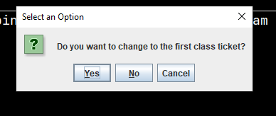

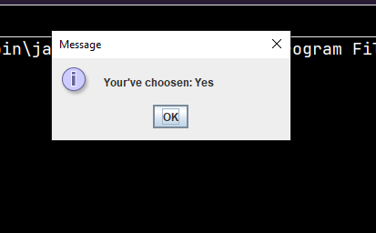

6.2- Write a program for input/output from keyboard

a. Code:

b. Thực thi:

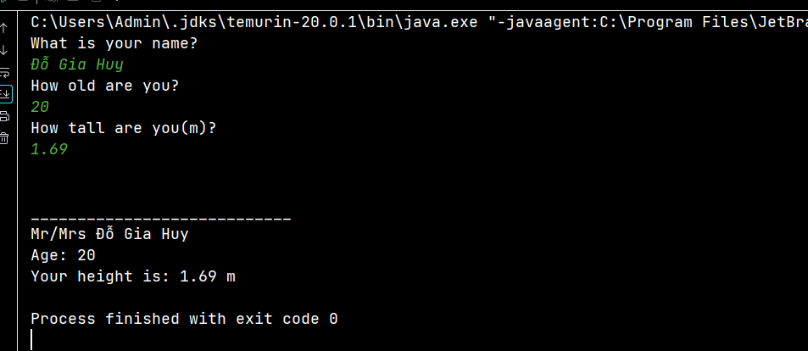

6.3- Write a program to display a triangle with a height of n stars (*), n is entered by users.

a. Code:

b. Thực thi:

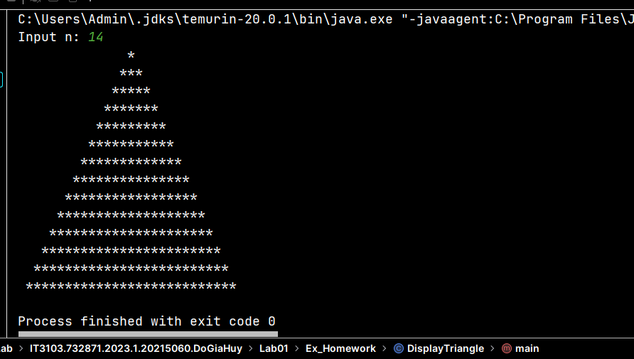

6.4- Write a program to display the number of days of a month, which is entered by users (both month and year). If it is an invalid month/year, ask the user to enter again.

a. Code:

b. Thực thi:

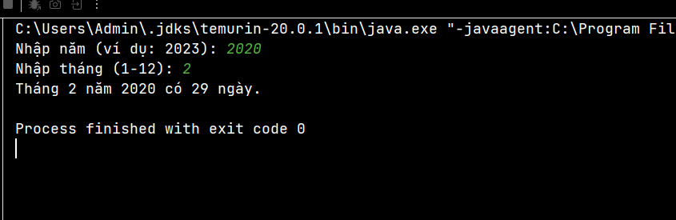

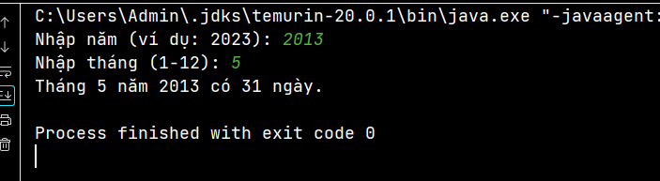

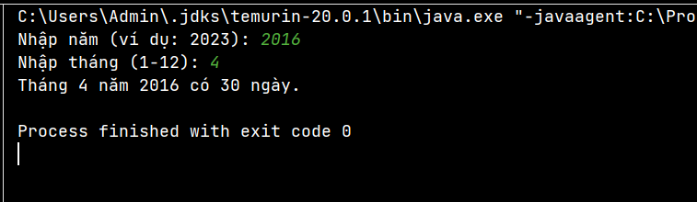

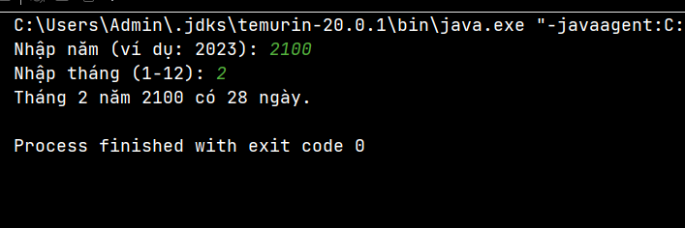

6.5- Write a Java program to sort a numeric array, and calculate the sum and average value of array elements.

a. Code:

b. Thực thi:

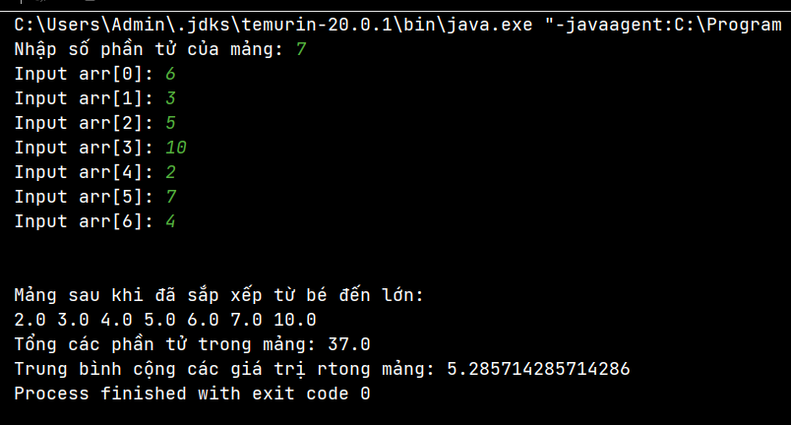

6.6- Write a Java program to add two matrices of the same size.

a. Code:

b. Thực thi:

